### 2. Model selection using autoDI()

#### Code for running autoDI()

# Since treatment is a categorical variable. Convert it to a factor before modelling  
# This is dplyr pipeline which is very useful for manipulating dataframe  
# '%>%' is called the pipe operator and simply passes the object on the left  
# side to a function on the right  
model_data <- model_data %>%   
 # The mutate function is used to add new columns to a data-frame  
 # We add a new column called "treatF" which is a factor  
 mutate("treatF" = factor(treatment))  
# The code might look daunting but is very handy for complex data manipulation  
# operations as we will see later.  
# The above code is equivalent to running the following  
# model_data$treatF <- factor(model_data$treatment)  
  
auto_mod <- autoDI(# y specifies the name of the column containing response  
 y = "yield",   
 # prop accepts the names of columns containing species proportions   
 prop = c("p1", "p2", "p3", "p4"),   
 # the name of column containing treatments (if present) goes in treat  
 treat = "treatF",  
 # FG accepts a character string describing functional grouping of species  
 FG = c("G", "G", "L", "L"),  
 # step0 tests against an intercept only model  
 step0 = TRUE,  
 # Finally, data accepts name of data-frame with these columns  
 data = model_data)

#### Equations of models fit by autoDI() at each step

##### Step0: Investigating non-diversity experimental structures

##### Step 1: Investigating

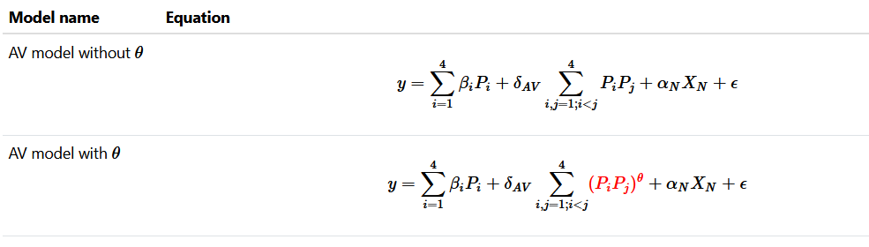

##### Step 2: Investigating interaction structures

##### Step 3: Investigating effect of treatment

##### Step 4: Assessing lack of fit

##### Best model selected by autoDI()

$$y=β_{1}P_{1}+β_{2}P_{2}+β_{3}P_{3}+β_{4}P_{4}+ω_{GL}\left[\left(P_{1}+P_{2}\right)\left(P_{3}+P_{4}\right)\right]+ω_{G}\left(P_{1}P_{2}\right)+ω_{L}\left(P_{3}P_{4}\right)+ϵ$$

summary(auto_mod)

##### Predicting for a 50:50 grass mixture

$$P_{1}=0.5;P_{2}=0.5;P_{3}=0;P_{4}=0$$

$$\hat{y}=10.88*0.5+12.0*0.5+6.24*0+9.48*0+20.81*\left(0.5+0.5\right)*\left(0+0\right)+17.62*\left(0.5*0.5\right)+9.05*\left(0*0\right)$$

$$\hat{y}=10.88*0.5+12.0*0.5+17.62*\left(0.5*0.5\right)$$

$$\hat{y}=15.85$$

##### Predictions for specific communities using model selected by autoDI()

# Extract the four monocultures, 50:50 grass and legume mixtures and   
# centroid community from data  
subset_comms <- model_data %>%   
 # Filter the specific communities by their number in the dataset  
 filter(community %in% c(1, 2, 3, 4, 5, 6, 27)) %>%   
 # Remove any duplicates  
 distinct(p1, p2, p3, p4)  
  
subset_comms  
  
# Use the prediction_contributions function from DImodelsVis package  
prediction_contributions(# model accepts a DImodel object  
 model = auto_mod,   
 # data accepts a data-frame with species communities to show on plot  
 data = subset_comms,  
 # bar_labs can be used to give labels to the X-axis  
 bar_labs = c("G1", "G2", "L1", "L2", "GG", "LL", "GGLL"))